IMBD database

## Problem Statement:

Using MySQL, design a database whose name is IMDB. Create proper MySQL tables, Primary Key, Foreign Key, add data into the MySQL tables and do the following as given below

1) 1. Movie should have multiple media (Video or Image)

2) 2. Movie can belong to multiple Genre

3) 3. Movie can have multiple reviews and Review can belongs to a user

4) 4. Artist can have multiple skills

5) 5. Artist can perform multiple roles in a single film

## Solution SQL Query:

Step 1: Create the Database

DROP DATABASE IF EXISTS IMDB;

CREATE DATABASE IMDB;

USE IMDB;

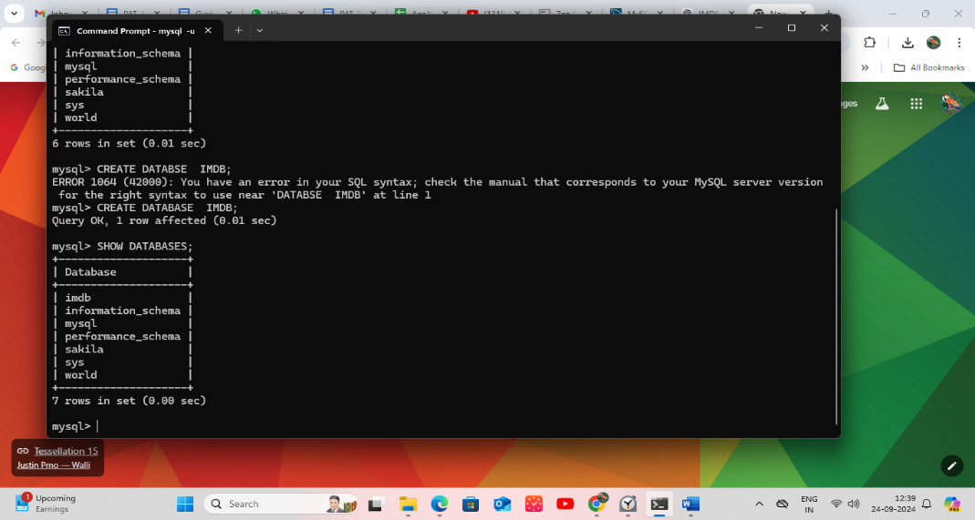

Step 2: Create the Tables

Movies Table:

---------------------------------------------------

CREATE TABLE Movies (

movie_id INT AUTO_INCREMENT PRIMARY KEY,

title VARCHAR(255),

release_year INT

);

---------------------------------------------------

Media Table:

CREATE TABLE Media (

media_id INT AUTO_INCREMENT PRIMARY KEY,

movie_id INT,

media_type ENUM('Video', 'Image'),

media_url VARCHAR(255),

FOREIGN KEY (movie_id) REFERENCES Movies(movie_id)

);

---------------------------------------------------

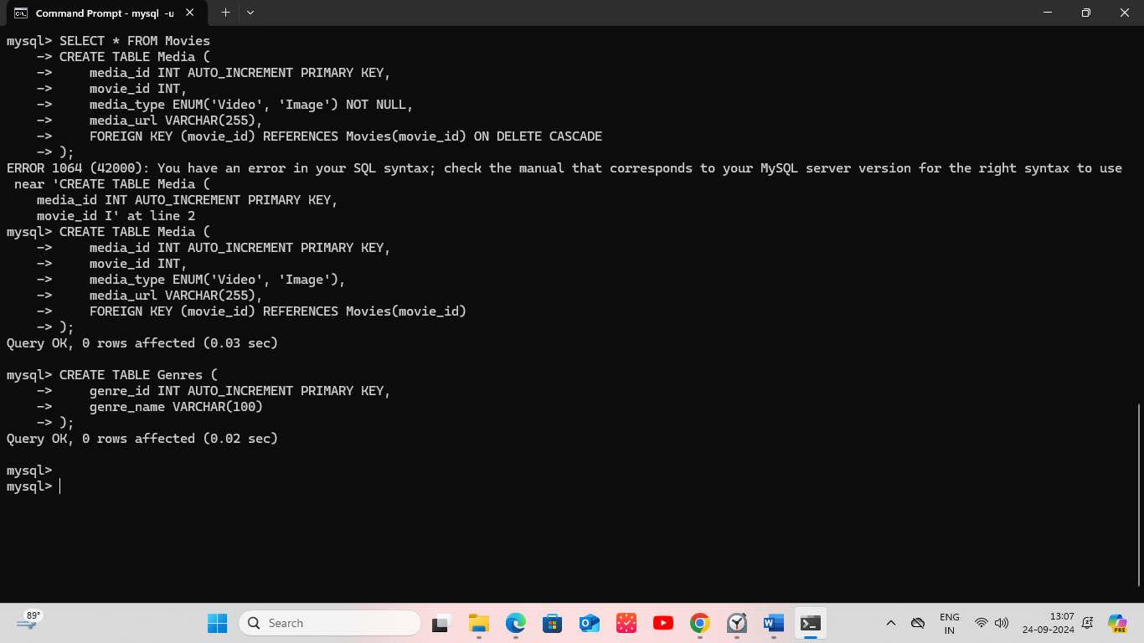

Genres Table:

CREATE TABLE Genres (

genre_id INT AUTO_INCREMENT PRIMARY KEY,

genre_name VARCHAR(100)

);

---------------------------------------------------

Movie_Genres Table:

CREATE TABLE Movie_Genres (

movie_id INT,

genre_id INT,

PRIMARY KEY (movie_id, genre_id),

FOREIGN KEY (movie_id) REFERENCES Movies(movie_id),

FOREIGN KEY (genre_id) REFERENCES Genres(genre_id)

);

---------------------------------------------------

Users Table:

CREATE TABLE Users (

user_id INT AUTO_INCREMENT PRIMARY KEY,

username VARCHAR(255)

);

---------------------------------------------------

Reviews Table:

CREATE TABLE Reviews (

review_id INT AUTO_INCREMENT PRIMARY KEY,

movie_id INT,

user_id INT,

review_text TEXT,

FOREIGN KEY (movie_id) REFERENCES Movies(movie_id),

FOREIGN KEY (user_id) REFERENCES Users(user_id)

);

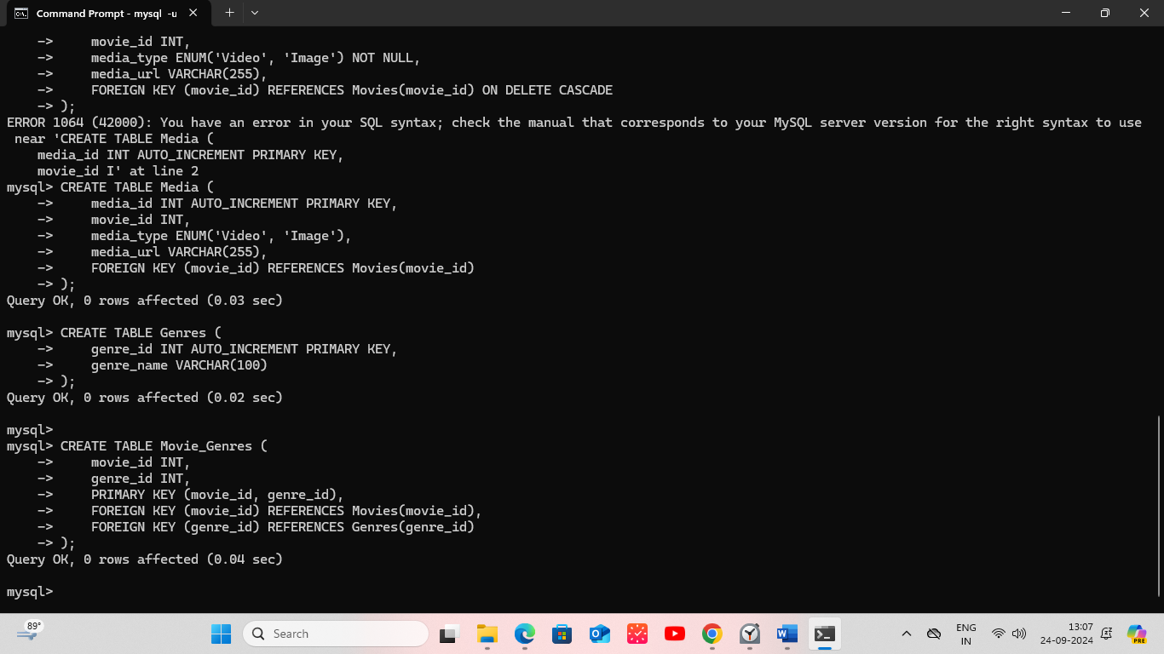

---------------------------------------------------

Artists Table:

CREATE TABLE Artists (

artist_id INT AUTO_INCREMENT PRIMARY KEY,

name VARCHAR(255)

);

---------------------------------------------------

Skills Table:

CREATE TABLE Skills (

skill_id INT AUTO_INCREMENT PRIMARY KEY,

skill_name VARCHAR(100)

);

---------------------------------------------------

Artist_Skills Table:

CREATE TABLE Artist_Skills (

artist_id INT,

skill_id INT,

PRIMARY KEY (artist_id, skill_id),

FOREIGN KEY (artist_id) REFERENCES Artists(artist_id),

FOREIGN KEY (skill_id) REFERENCES Skills(skill_id)

);

---------------------------------------------------

Roles Table:

CREATE TABLE Roles (

role_id INT AUTO_INCREMENT PRIMARY KEY,

role_name VARCHAR(255)

);

---------------------------------------------------

Movie_Artist_Roles Table:

CREATE TABLE Movie_Artist_Roles (

movie_id INT,

artist_id INT,

role_id INT,

PRIMARY KEY (movie_id, artist_id, role_id),

FOREIGN KEY (movie_id) REFERENCES Movies(movie_id),

FOREIGN KEY (artist_id) REFERENCES Artists(artist_id),

FOREIGN KEY (role_id) REFERENCES Roles(role_id))

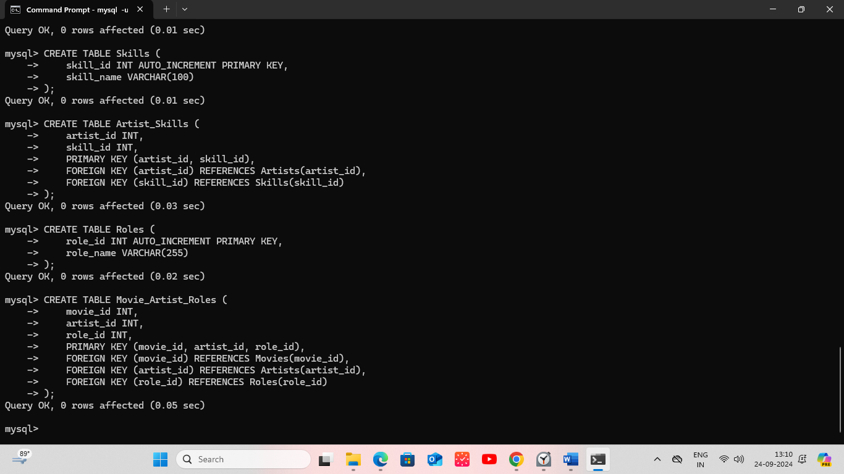

Step 3: CRUD Operations

-- Insert Movies

INSERT INTO Movies (title, release_year) VALUES

('Inception', 2010),

('The Matrix', 1999),

('Interstellar', 2014),

('Avatar', 2009),

('The Dark Knight', 2008);

-- Insert Media

INSERT INTO Media (movie_id, media_type, media_url) VALUES

(1, 'Video', 'https://inception_trailer.com'),

(1, 'Image', 'https://inception_poster.com'),

(2, 'Video', 'https://matrix_trailer.com'),

(2, 'Image', 'https://matrix_poster.com');

-- Insert Genres

INSERT INTO Genres (genre_name) VALUES

('Sci-Fi'),

('Action'),

('Adventure'),

('Drama'),

('Fantasy');

-- Insert Movie Genres

INSERT INTO Movie_Genres (movie_id, genre_id) VALUES

(1, 1), (1, 2),

(2, 1), (2, 2),

(3, 1), (3, 3);

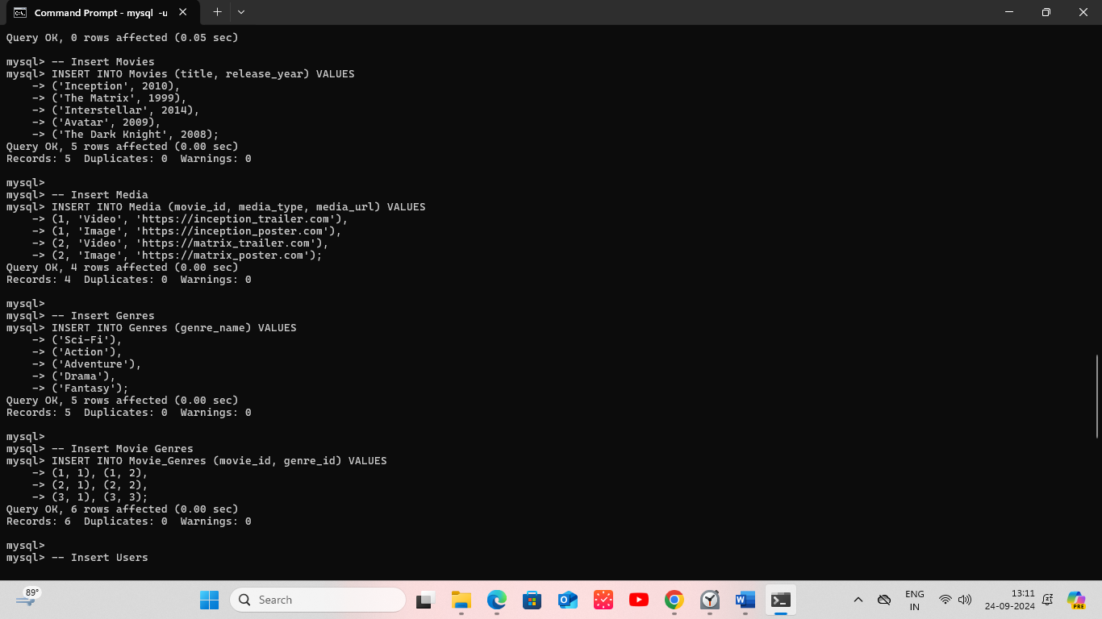

-- Insert Users

INSERT INTO Users (username) VALUES

('john_doe'),

('jane_smith');

-- Insert Reviews

INSERT INTO Reviews (movie_id, user_id, review_text) VALUES

(1, 1, 'Great movie!'),

(2, 2, 'A sci-fi masterpiece.');

-- Insert Artists

INSERT INTO Artists (name) VALUES

('Leonardo DiCaprio'),

('Keanu Reeves');

-- Insert Skills

INSERT INTO Skills (skill_name) VALUES

('Acting'),

('Directing');

-- Insert Artist Skills

INSERT INTO Artist_Skills (artist_id, skill_id) VALUES

(1, 1), (2, 1);

-- Insert Roles

INSERT INTO Roles (role_name) VALUES

('Lead Actor'),

('Director');

-- Insert Movie Artist Roles

INSERT INTO Movie_Artist_Roles (movie_id, artist_id, role_id) VALUES

(1, 1, 1),

(2, 2, 1);

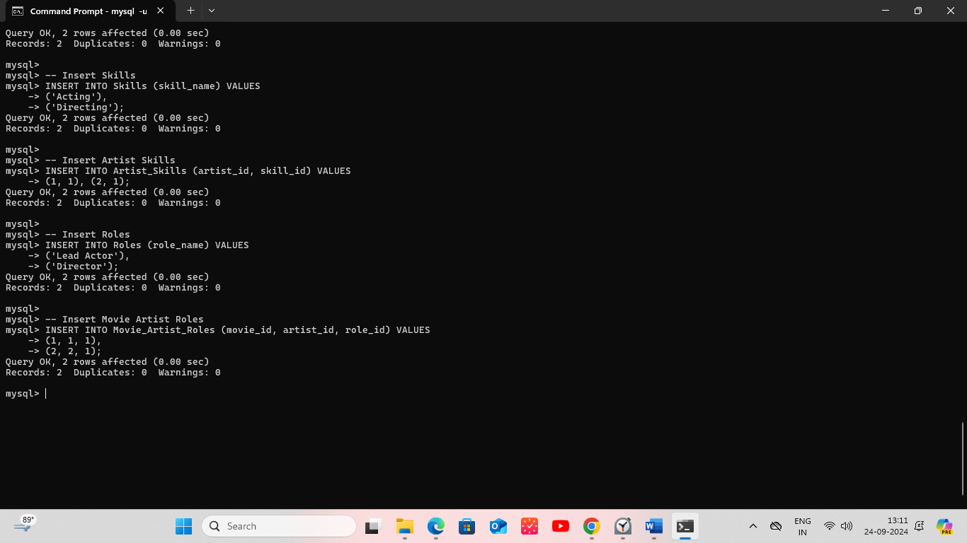

**Read:**

SELECT * FROM Movies;

SELECT * FROM Reviews WHERE movie_id = 1;

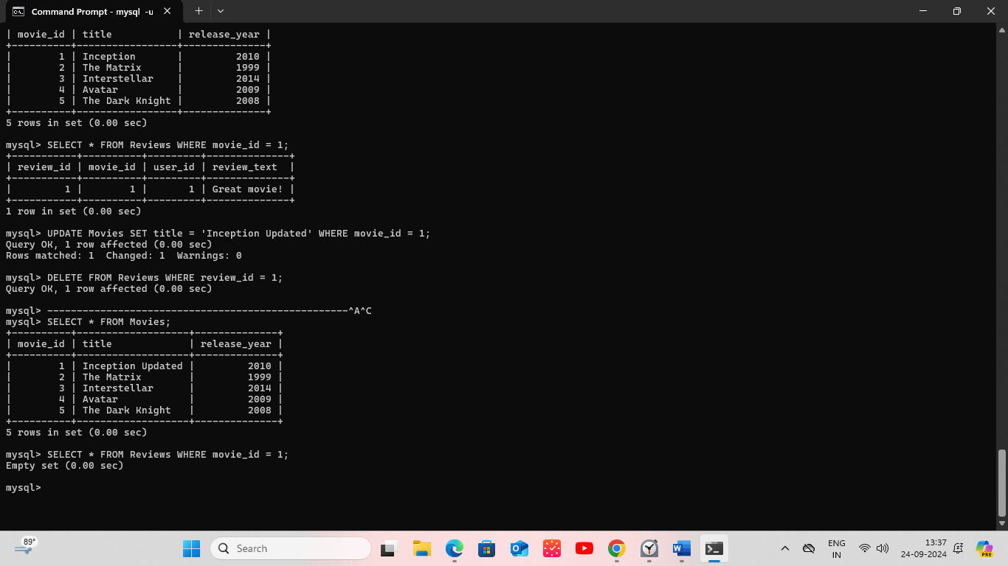

**Update:**

UPDATE Movies SET title = 'Inception Updated' WHERE movie_id = 1;

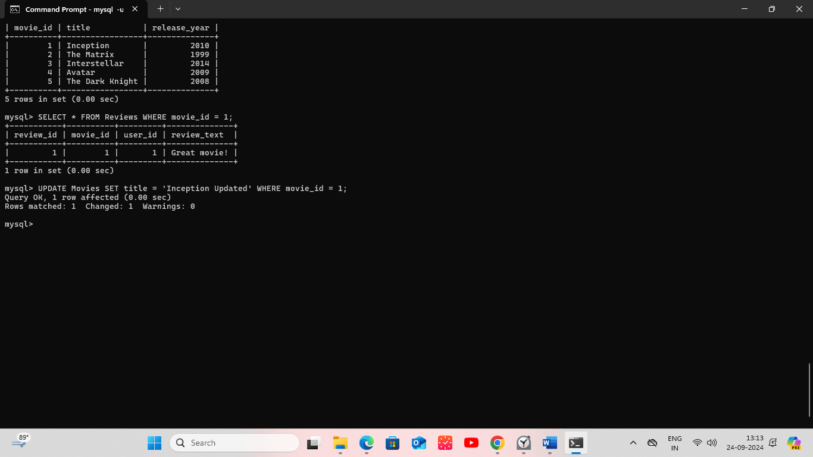

**Delete:**

DELETE FROM Reviews WHERE review_id = 1;

